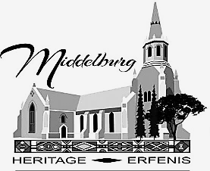 | MIDDELBURG  MPUMALANGA  HERITAGE | 

HERITAGE ASSOCIATION OF SOUTH AFRICA PRESENTS

24TH ANNUAL SYMPOSIUM – 13 TO 16 OCTOBER 2025

SECOND CIRCULAR - MAY 2025

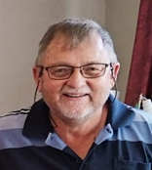  Rudi van Wyk  Convenor | Rudi van Wyk – Symposium Convenor  082 569 8510  Soekie Rossouw - Secretary  082 922 7498  rossouwsonnet@gmail.com | 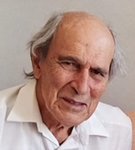  Kobus Terblanche  Patron
Delegates and Friends
You are hereby invited to submit a abstract or presentation for possible inclusion in this symposium. Abstracts for lectures and poster presentations must be submitted via email to ajbotha1953@gmail.com on or before 1 September 2025. An abstract for lecture should be between 200 to 300 words, to be presented in a timeslot of 35 minutes. The timeslot for poster presentations will be 15 minutes.

The theme for the Symposium is : “Historical Middelburg, the Gateway to History”.
You are invited to write your papers, or prepare your posters surrounding any of the following suggested topics:

Dark Heritage  Cultural Heritage  Historical Heritage  Natural Heritage  Argricultural and Industrial Heritage  Social and Political Heritage | Spiritual and Religious Heritage  Archaeological Heritage  Intangible Heritage  Conservation Heritage  Anglo Boer War

You are however not limited to these suggested topics. We look forward to be intrigued by your expertise, knowledge and vision walking back in time through this unique gateway to the past.

IMPORTANT DATES :

Paper and Poster Deadline : 1 September
Registration Deadline : 21 September

PRELIMINARY PROGRAMME

ARRIVAL | ITINERARY |  | VENUE
Monday  13 October | 14:00 – 20:00 | Registration  Ice Breaker – Enjoy snacks, wine and good company | Commemorative Hall

DAY 1 | ITINERARY |  | VENUE
Tuesday  14 October | 07:00 – 13:30 | Heritage Book Sales Kiosk | Country Club
Tuesday  14 October | 07:00 – 08:15 | Registration | Country Club
Tuesday  14 October | 08:00 – 09:00 | Welcome Address & Symposium Opening | Country Club
Tuesday  14 October | 09:00 – 10:30 | 2 Lectures & discussion time | Country Club
Tuesday  14 October | 10:30 – 11:00 | Tea / coffee and snacks | Country Club
Tuesday  14 October | 11:00 – 11:30 | 2 Poster presentations | Country Club
Tuesday  14 October | 11:30 – 13:00 | 2 Lectures & discussion time | Country Club
Tuesday  14 October | 13:00 – 14:00 | Lunch | Country Club
Tuesday  14 October | 14:00 – 15:30 | Virtual Tour | Country Club
Tuesday  14 October | 15:30 – 16:00 | Travel to White Church | White Church
Tuesday  14 October | 16:00 – 17:30 | Landmarks and Organ Presentation | White Church
Tuesday  14 October | 18:00 | Dinner | Country Club
Tuesday  14 October | 19:00 | HASA AGM | Country Club

DAY 2 | ITINERARY |  | VENUE
Wednesday  15 October | 07:00 – 13:30 | Heritage Book Sales Kiosk | Country Club
Wednesday  15 October | 07:00 – 08:30 | Registration – Day Visitors | Country Club
Wednesday  15 October | 08:30 – 10:00 | 2 Lectures & discussion time | Country Club
Wednesday  15 October | 10:00 – 10:30 | 2 Poster Presentations | Country Club
Wednesday  15 October | 10:30 – 11:00 | Tea / coffee and snacks | Country Club
Wednesday  15 October | 11:00 – 12:30 | 2 Lectures & discussion time | Country Club
Wednesday  15 October | 12:30 – 12:45 | Powder nose time | Country Club
Wednesday  15 October | 12:45 – 13:13 | 2 Poster Presentations | Country Club
Wednesday  15 October | 13:15 – 14:15 | Lunch | Country Club
Wednesday  15 October | 14:15 – 14:45 | Travel to Old Railway Station | Old Railway Station
Wednesday  15 October | 14:45 – 16:00 | Visit Railway Station and Meijer Bridge | Old Railway Station
Wednesday  15 October | 18:00 | Gala Dinner  Address by Kathy Munro, HASA Chair  Gold Medal of Achievement  Music by Nantes and Adelle Du Plessis | Country Club

PRELIMINARY PROGRAMME

DAY 3 | ITINERARY |  | VENUE
Thursday  16 October | 07:00 – 13:30 | Heritage Book Sales Kiosk | Country Club
Thursday  16 October | 07:00 – 08:30 | Registration – Day Visitors
Thursday  16 October | 08:30 – 10:00 | 2 Lectures & discussion time
Thursday  16 October | 10:00 – 10:30 | 2 Poster Presentations
Thursday  16 October | 10:30 – 11:00 | Tea/ coffee and snacks
Thursday  16 October | 11:00 – 12:30 | 2 Lectures & discussion time
Thursday  16 October | 12:30 – 12:45 | Powder nose time
Thursday  16 October | 12:45 – 13:15 | 2 Poster presentations
Thursday  16 October | 13:15 – 14:15 | Lunch
Thursday  16 October | 14:15 – 14:45 | Travel to ABW Cemetery | ABW Cemetery
Thursday  16 October | 14:45 – 16:30 | ABW Cemetery and Old Block house | ABW Cemetery
Thursday  16 October | 18:00 | Symposium Closing address from MHA  Traditional Braai | Country Club

SYMPOSIUM COSTS

Arrival | 13 October | Ice Breaker – snacks and wine - Free
Symposium Costs | 14 – 16 October | 3-day full registration cost |  | R 950.00
Symposium Costs | 14 – 16 October | Single day cost |  | R 320.00
Tea / coffee and snacks | 14 – 16 October | Included in Registration fee
All lunches | 14 – 16 October | Own cost
Dinners | 14 – 16 October | Own cost
Gala Dinner | 15 October | R 350.00
Traditional Braai | 16 October | R 260.00
Excursions | 14- 16 October | Free – own transport
Extended excursion | 17 October | Round of Golf – own cost
In Circular 3 you will be furnished with a list of accommodation and contact details.

Kind regards

Rudi van Wyk
Symposium Convener
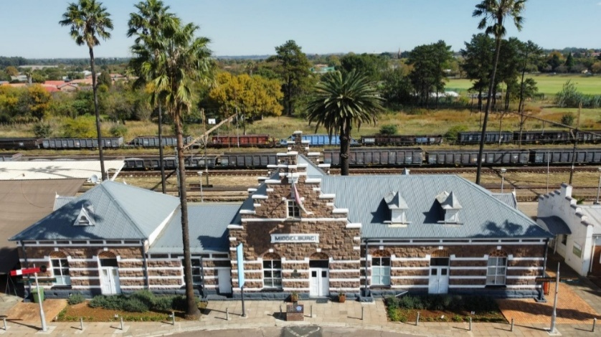
Photo of Old Railway Station

